**Github DO NOTS**

1. **Do NOT push into the master branch. Any commits pushed directly to master will be removed and you will have to redo your work.**
2. **Do NOT rename files that have been pushed to the repo, you only rename files that ONLY exist on your local copy.**

**Link for github Desktop App**

<https://desktop.github.com/>

**Cloning repo locally**

In the repo you can click on clone/download, and select open in desktop. This will open the desktop program and you can choose where to save the repo from there.

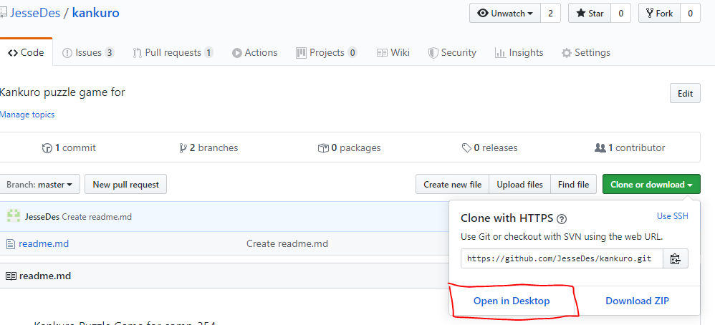

**Creating a branch**

1. Make sure you are currently starting from the master branch (or the branch you wish to branch off of)

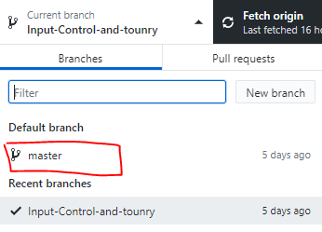



1. Once your current branch is master open the branch menu again and select new branch

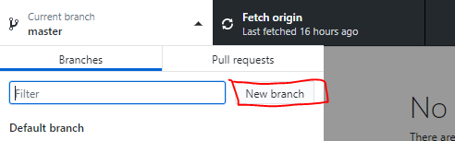

1. This branch will only exist on your computer until you publish it, so just publish it and then you can work like normal

**Committing and pushing changes**

In order for your work to save you need to commit, and push them. Commits will save the changes locally and pushing it will put those commits on the online repo.

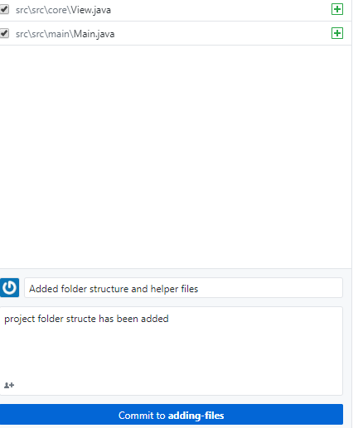

You should commit every time you stop working and push every time you complete a task or part of a larger task.

To commit you fill out the box on the bottom left with a descriptive title, and more detailed description and click commit:

You can undo any work in a file you no longer wish to commit by right clicking on it in the change list and selecting “Discard changes”

Once you make your commit, you can push to origin by clicking the button up top.



**Making Pull request and merging into Master**

Before you create a pull request you first need to make sure no changes happened since you branched that could broke your code. So, you need to merge master into your branch and test your code again, and resolve any code conflicts that come up.

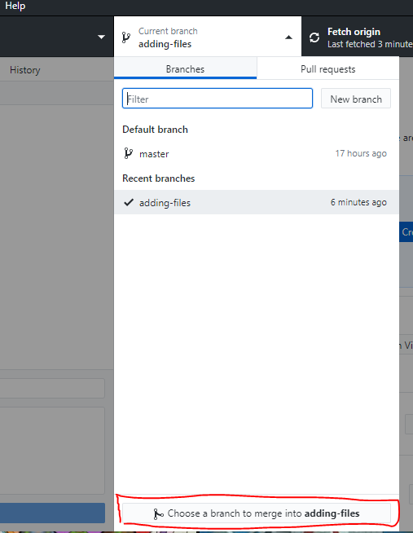

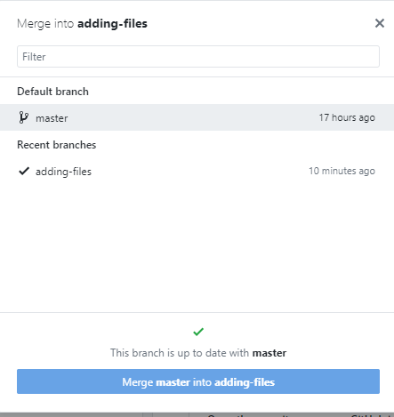

Select master

To merge into your branch.

If there are no changes it will tell you that the branch is up to date and not let you merge.

It should automatically commit and push after the merge, but if it doesn’t be sure to do so. (if it did not push, you will see files in the list of changed files)

Once you are merged with master and all changes have been pushed, on the repo website you should see something like this. Click the button to create a Pull request.

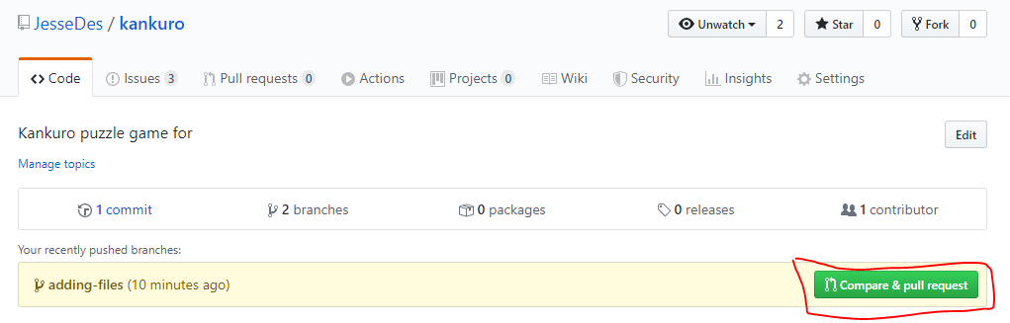

If that button does not show up you have to select your branch then create a new pull request

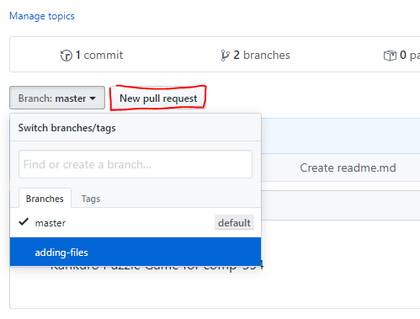

Make sure the PR is “Able to merge” otherwise you most likely forget to merge master or a change was done before you made your pull request. Also don’t forget to tag the other coders to review your code. You cannot merge your pull request until 2 others approve it.

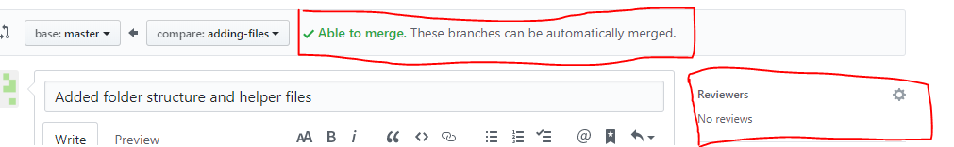

Once it has been approved by the others you will see the following option, just click merge to finalize the process.

